Software Engineering Assignment

MODULE: 1

SE – Overview of IT Industry

**Q1. What is software? What is software engineering?**

**Ans: Software:** A set of instructions or programs that tell a computer what to do. It's a collection of data, instructions, and algorithms that manage, control, and utilize computer hardware components or perform specific tasks.

**Software Engineering:** The systematic application of engineering approaches to the development of software. It involves designing, building, testing, maintaining, and adapting software systems to meet specific requirements and ensure quality, reliability, and efficiency. Software engineering encompasses various stages, including analysis, design, implementation, testing, and maintenance, using various methodologies, tools, and techniques to produce high-quality software products.

**Q2. Explain types of software** :

Ans :

Application software :

Application the most common. Software application host Software is a Computer Software package that performs a specific function for a user, or in same Cases, for another app

Ex paint, power point, etc.

System software :

system these software programs are designed to rum a computer's application program and hardware

Ex Notepad, Calculator etc.

Driver software :

Driver software also known as device drivers, this software is often considered a types of system software . the devices and peripheral .

Device driver control

Eg. video driver, Audio driver etc.

Middleware:

Middle ware the term middleware describes software that mediates between app and System Software or between two different kinds of app soft ware.

Eg. database middle ware, app Server Media.

Programming software :

Computer programmers use programming software to write code programming software and programming tools Enable development programming develop, write test, and program. debug other software

Programs.

**Q3. What is SDLC? Explain each phase of SDLC**

Ans : **Software Development Life Cycle (SDLC)** is a systematic process for planning, creating, testing, and deploying software applications. It provides a structured approach to software development and helps ensure the quality and efficiency of the final product. The SDLC typically consists of several phases, each with specific objectives and deliverables.

Steps of SDLC :

1. Planning: Identify project requirements, goals, and timelines.

2. Analysis: Gather and define project specifications, user needs, and technical requirements.

3. Design: Create a detailed blueprint of the software, including architecture, components, and user interface.

4. Implementation: Write the code, develop the software, and integrate components.

5. Testing and Integration: Verify software functionality, identify bugs, and ensure seamless integration.

6. Maintenance: Deploy, support, and update the software to ensure ongoing quality, security, and user satisfaction.

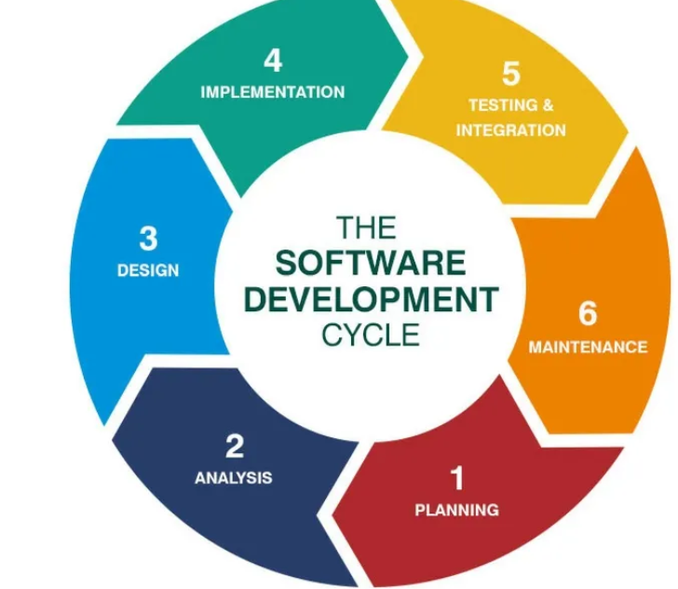

**Q4. What is DFD? Create a DFD diagram on Flipkart**

Ans : **Data Flow Diagram (DFD)** is a graphical representation of the flow of data within a system. It shows how data is processed by the system and how it moves between different components. DFDs help visualize the interactions between processes, data stores, and external entities, making them a useful tool for understanding and analyzing the system's functionality.

### Components of a DFD

1. **Processes:** Represent actions or transformations that change input data into output data. These are typically shown as circles or rectangles with rounded corners.
2. **Data Flows:** Indicate the movement of data between processes, data stores, and external entities. They are represented by arrows.
3. **Data Stores:** Represent storage locations for data within the system. These are typically shown as open-ended rectangles.
4. **External Entities:** Represent actors or systems outside the scope of the system being modeled that interact with it. These are usually depicted as rectangles.

### Example: DFD for Flipkart

Let’s create a simple Data Flow Diagram (DFD) for an e-commerce platform like Flipkart. We’ll create a Level 0 (Context Diagram) and a Level 1 DFD.

**Entities:**

* **Customer**: An external user who interacts with the Flipkart system.
* **Payment Gateway**: An external system for processing payments.

**Processes:**

* **Flipkart System**: Represents the entire e-commerce platform.

**Data Flows:**

* **Customer to Flipkart System:** Place Orders, Browse Products
* **Flipkart System to Payment Gateway:** Payment Details
* **Payment Gateway to Flipkart System:** Payment Confirmation
* **Flipkart System to Customer:** Order Confirmation, Product Information

**Processes:**

1. **Product Catalog Management:** Handles the display and management of product information.
2. **Order Processing:** Manages the creation and handling of orders.
3. **Payment Processing:** Interacts with the payment gateway to handle transactions.
4. **Customer Service:** Manages customer interactions and support.

**Data Stores:**

* **Product Database:** Stores product information.
* **Order Database:** Stores order details.

**Customer Database:** Stores customer information

**Diagram :**

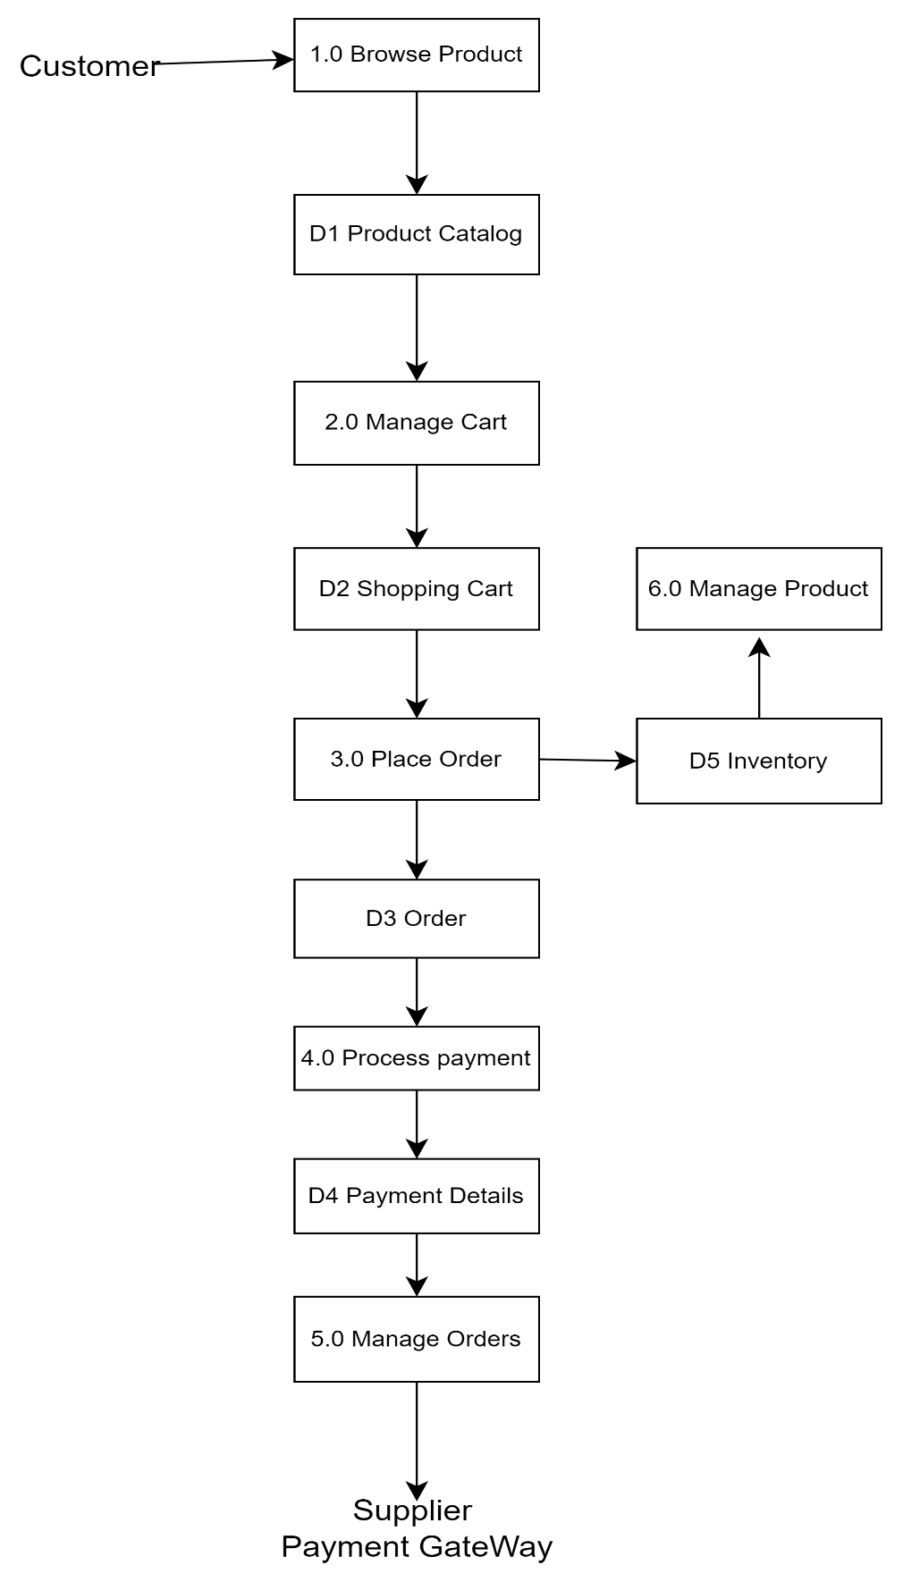

**Q5. What is Flow chart? Create a flowchart to make addition of two numbers**

**Ans : Flowchart** is a diagrammatic representation of a process or algorithm. It uses various symbols to illustrate the flow of control through different steps of a process. Flowcharts are helpful in understanding, analyzing, and designing processes or algorithms by visualizing each step in a clear and structured manner.

**Common Flowchart Symbols :**

1. **Start/End (Oval):** Indicates the beginning and end of the flowchart.
2. **Process (Rectangle):** Represents a process or action step.
3. **Input/Output (Parallelogram):** Shows where input is received or output is displayed.
4. **Decision (Diamond):** Represents a decision point that can lead to different paths based on conditions.
5. **Connector (Circle):** Connects different parts of the flowchart, especially in complex diagrams.
6. **Arrow (Line):** Shows the direction of flow between steps.

**Flowchart for Adding Two Numbers**

Here’s a simple flowchart to illustrate the process of adding two numbers:

1. **Start:** Begin the process.
2. **Input First Number:** Receive the first number from the user.
3. **Input Second Number:** Receive the second number from the user.
4. **Add Numbers:** Perform the addition operation on the two numbers.
5. **Display Result:** Show the result of the addition to the user.
6. **End:** Finish the process.

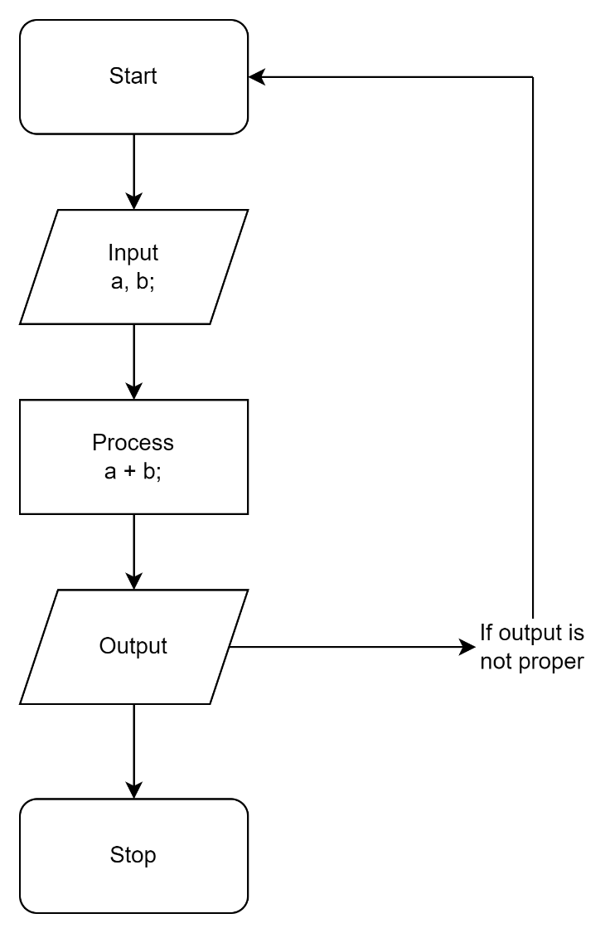

**Q6. What is Use case Diagram? Create a use-case on bill payment on paytm**

**Ans :** A Use Case Diagram is a type of behavioral diagram used in Unified Modeling Language (UML) to represent the functional requirements of a system. It shows the interactions between users (actors) and the system, illustrating how various functions or "use cases" fulfill the users' needs

**Components of a Use Case Diagram:**

1. **Actors**: Entities that interact with the system (e.g., users, external systems).
2. **Use Cases**: Specific functions or processes that the system performs (e.g., "Login", "Process Payment").
3. **System Boundary**: Defines the scope of the system.
4. **Relationships**: Connections between actors and use cases, and between use cases themselves (e.g., associations, generalizations, inclusions, and extensions).

**Use Cases**:

* **Login**
* **Select Bill Payment**
* **Enter Bill Details**
* **Choose Payment Method**
* **Confirm Payment**
* **Receive Confirmation**

